# User Guide Of Data Validation Service

* Background
* Architecture
* Use Case
  + Reporting Team - Cross Check
  + Fraud Team - Detailed metrics report
  + Merch Team - feature consistency
* Steps
  + Step1 - Create metrics rule
  + Step2 - Create Validation rule
    - Select Quality - Data Validation in left navigation bar → Click Add button
    - Fill in basic information
    - Add Accuracy rule
    - Add Consistency rule
    - Add triggers parameters
    - Add notifications
    - Select extra settings
* Examples
  + Data Consistency
  + Data Accuracy

# Background

As ads is a highly data driven system, data validation is a general requirement across teams. For example:

* Validate fraud clicks count between batch and real-time
* Validate feature consistency between online and offline
* Validate data consistency among different data sets in data pipeline, like validate metrics between clickhouse and hdfs(DSS)

In order to make it more convenient and flexible, we released self-service in Control Center.

# Architecture

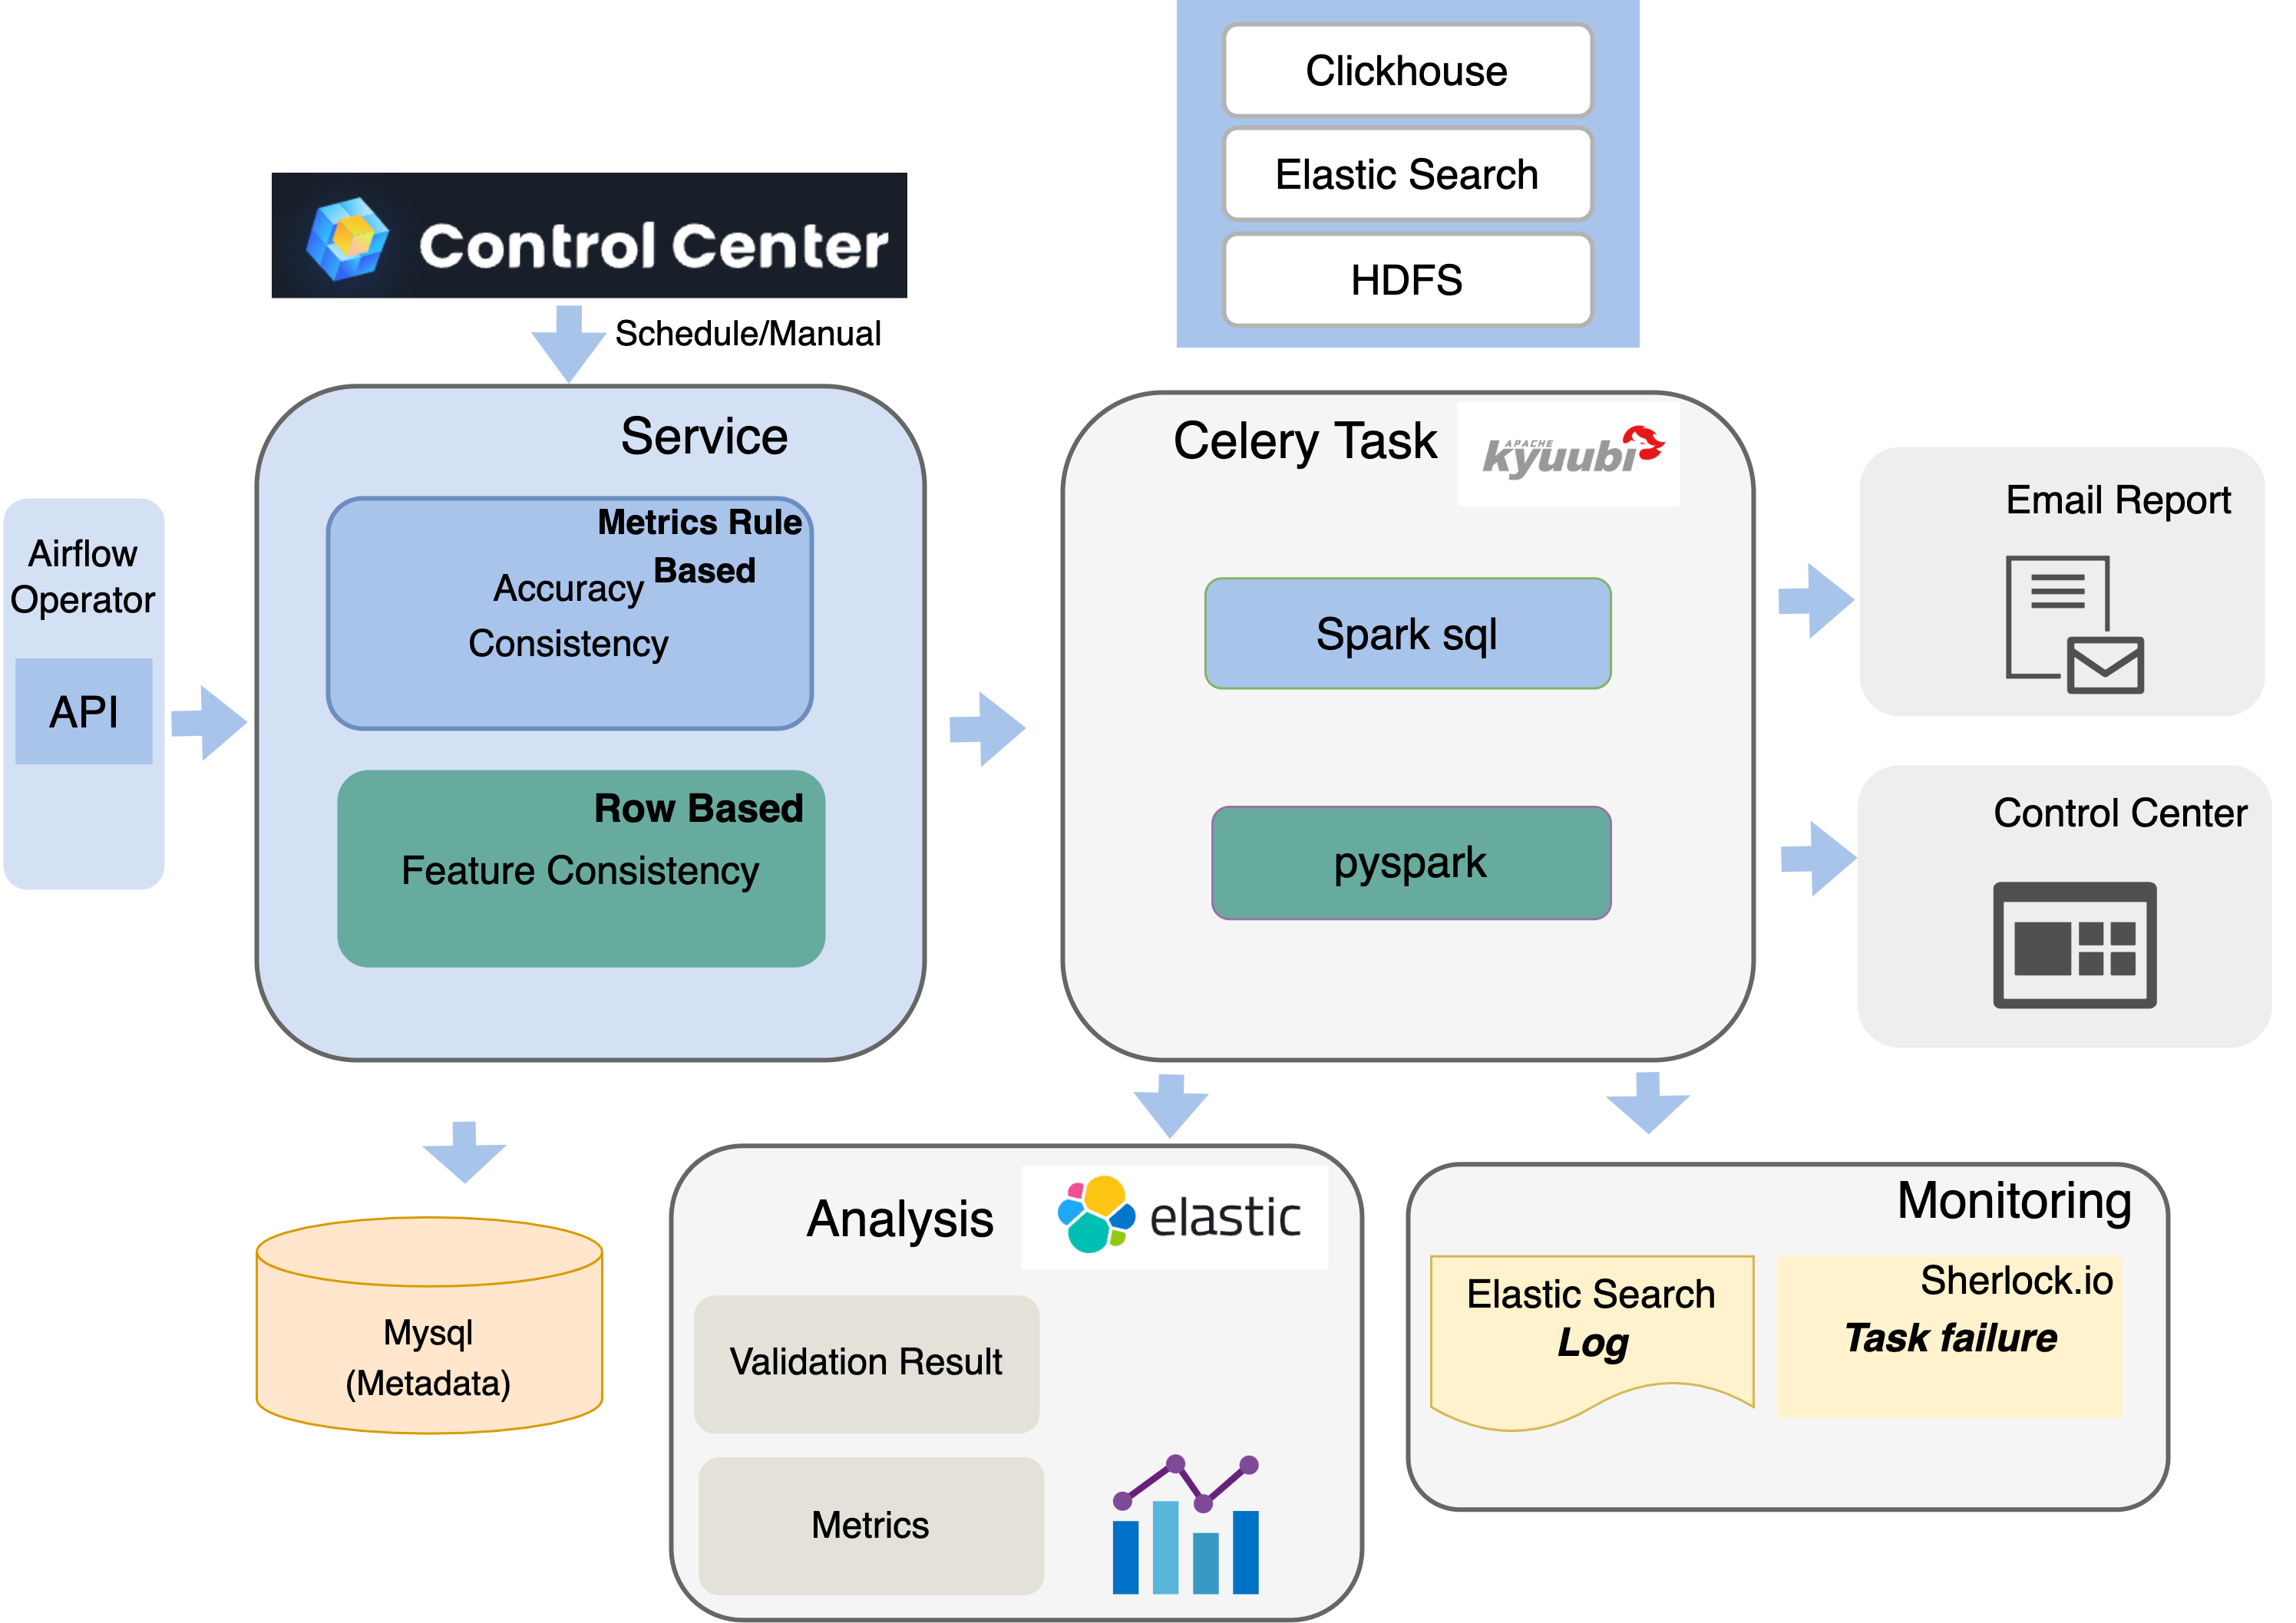

# Use Case

### Reporting Team - Cross Check

* Scheduled task, duration: 90 days
* Data source: Clickhouse, Hdfs

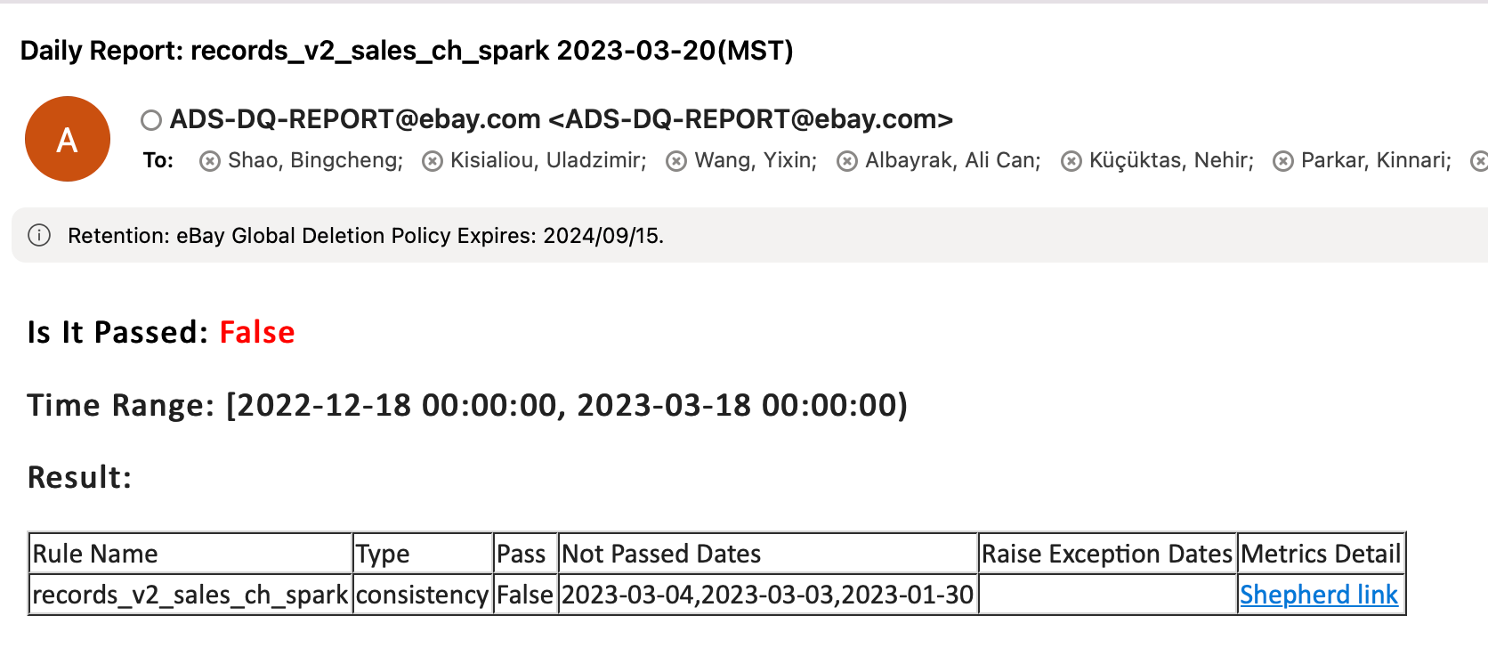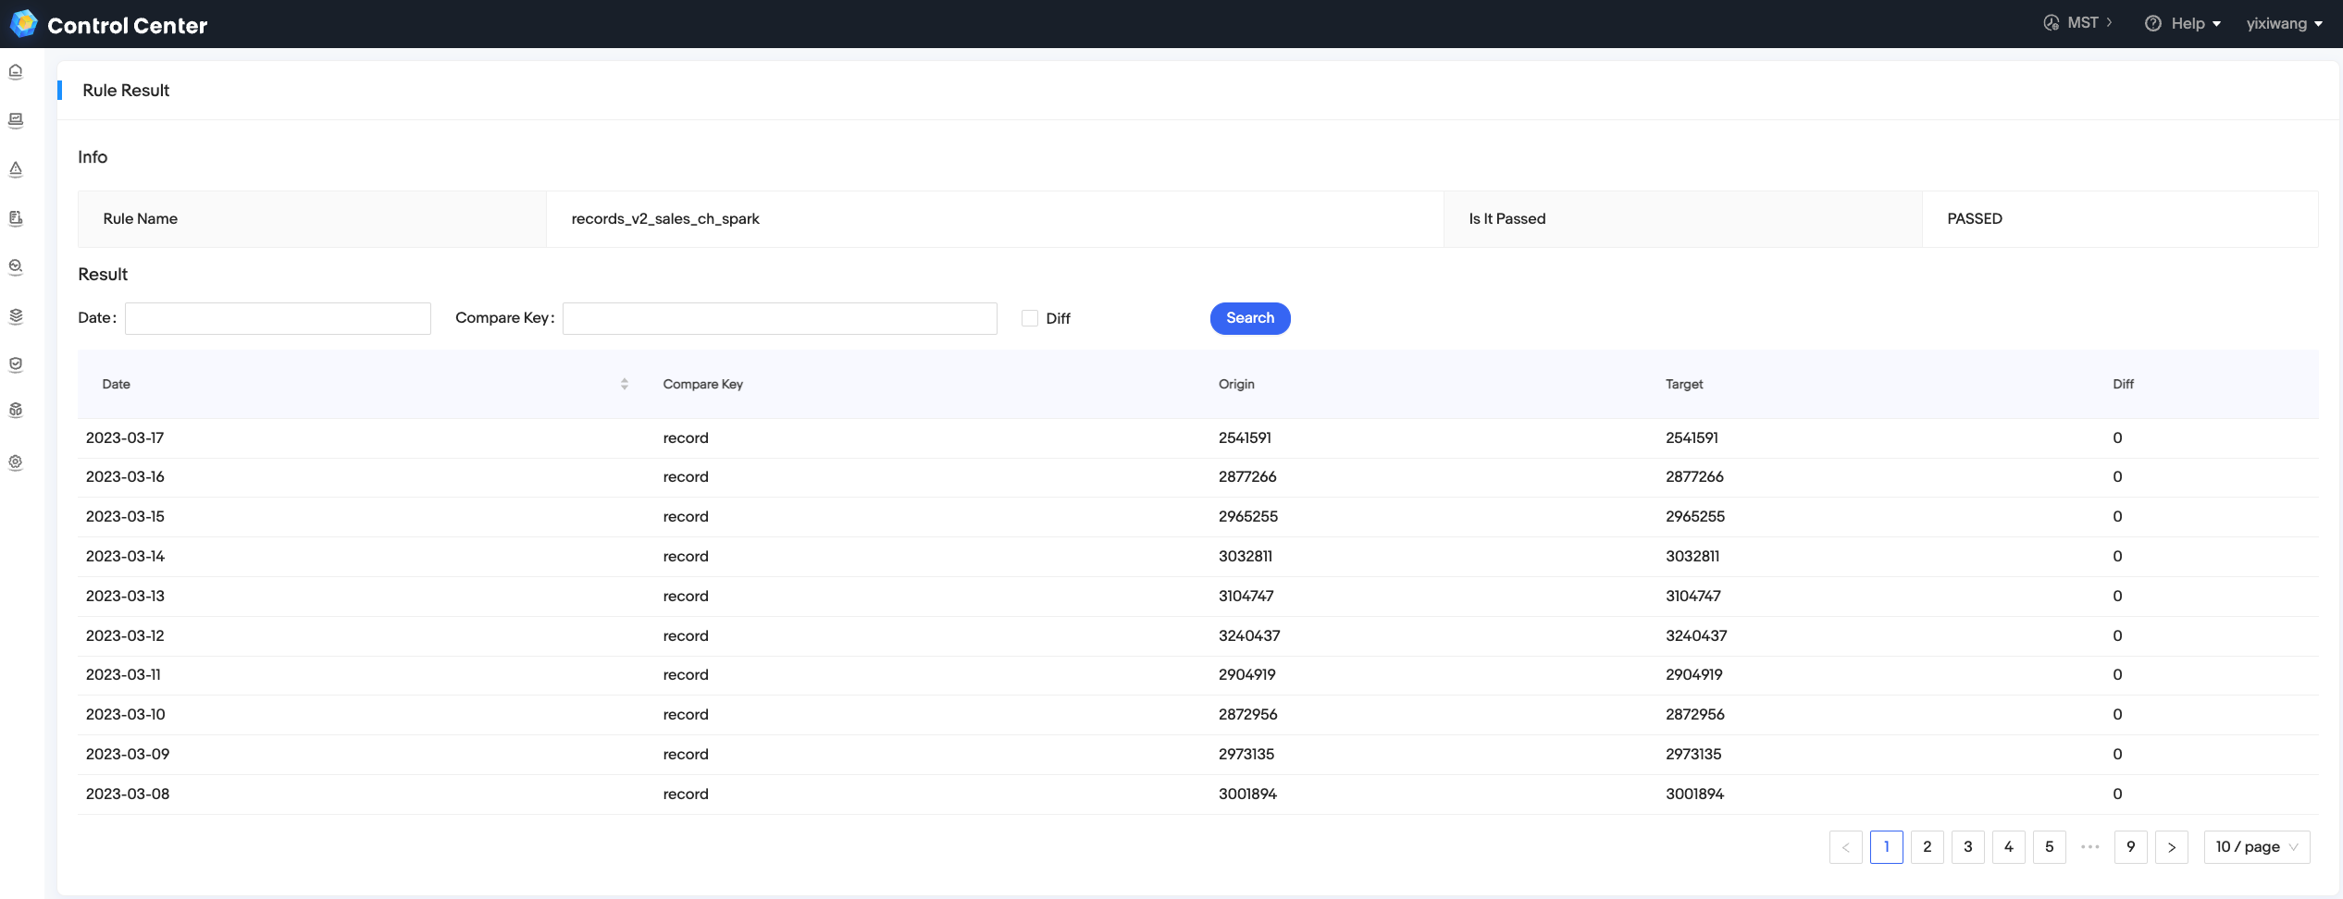

### Fraud Team - Detailed metrics report

* Scheduled task, duration: 1 day
* Data source: Hdfs

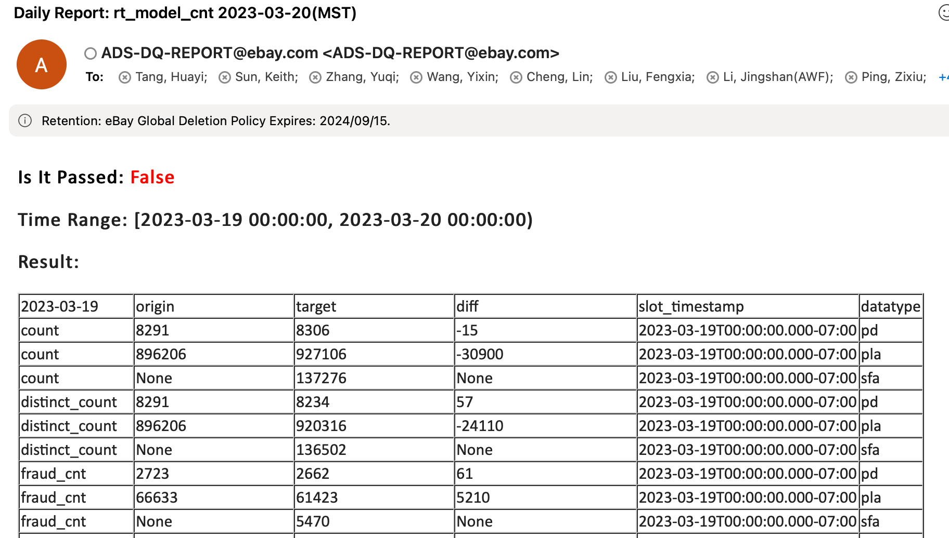

### Merch Team - feature consistency

* Integrate into Ads scheduler, use data validation as an operator
* Compare feature consistency between online and offline model, find out outliers to regulate model
* Supported metrcis:  count, min, max, diff_percentile, diff_ratio_percentile, consistency_ratio

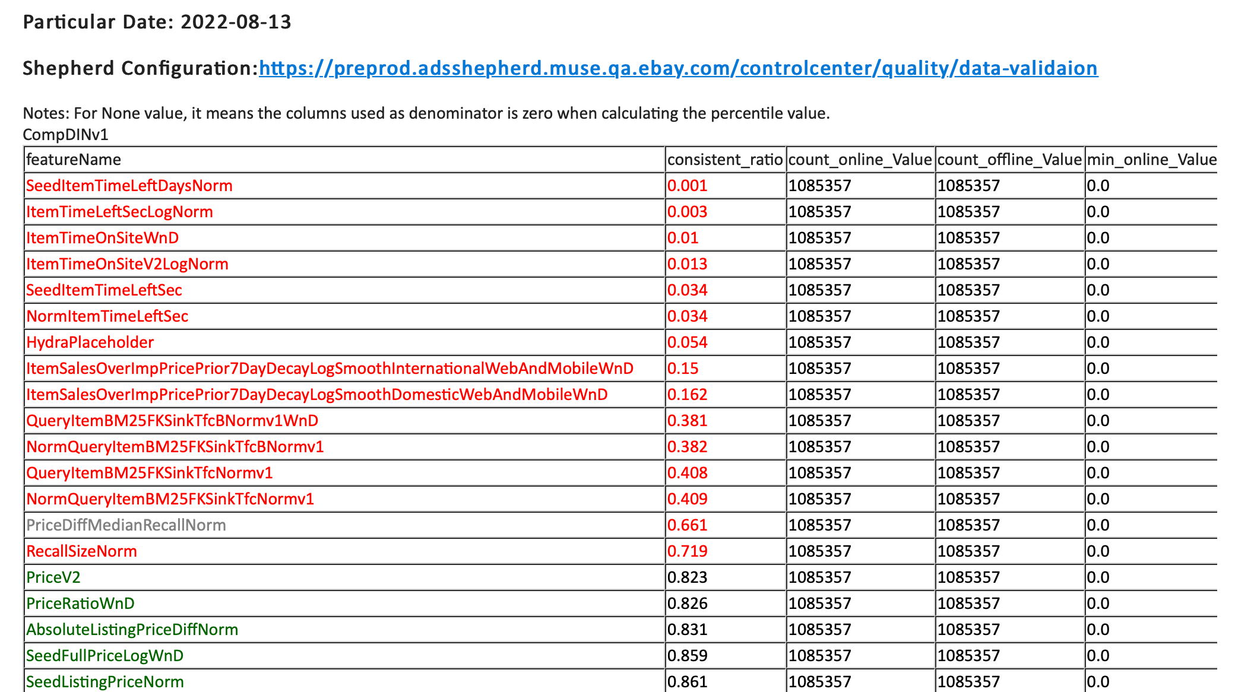

# Steps

### Step1 - Create metrics rule

[How to create a metrics rule in Control Center?](https://shepherd-api-adsshepherd.vip.ebay.com/docs/#/guide/monitoring_metrics_manager)

### Step2 - Create Validation rule

#### Select ****Quality - Data Validation**** in left navigation bar → Click ****Add**** button

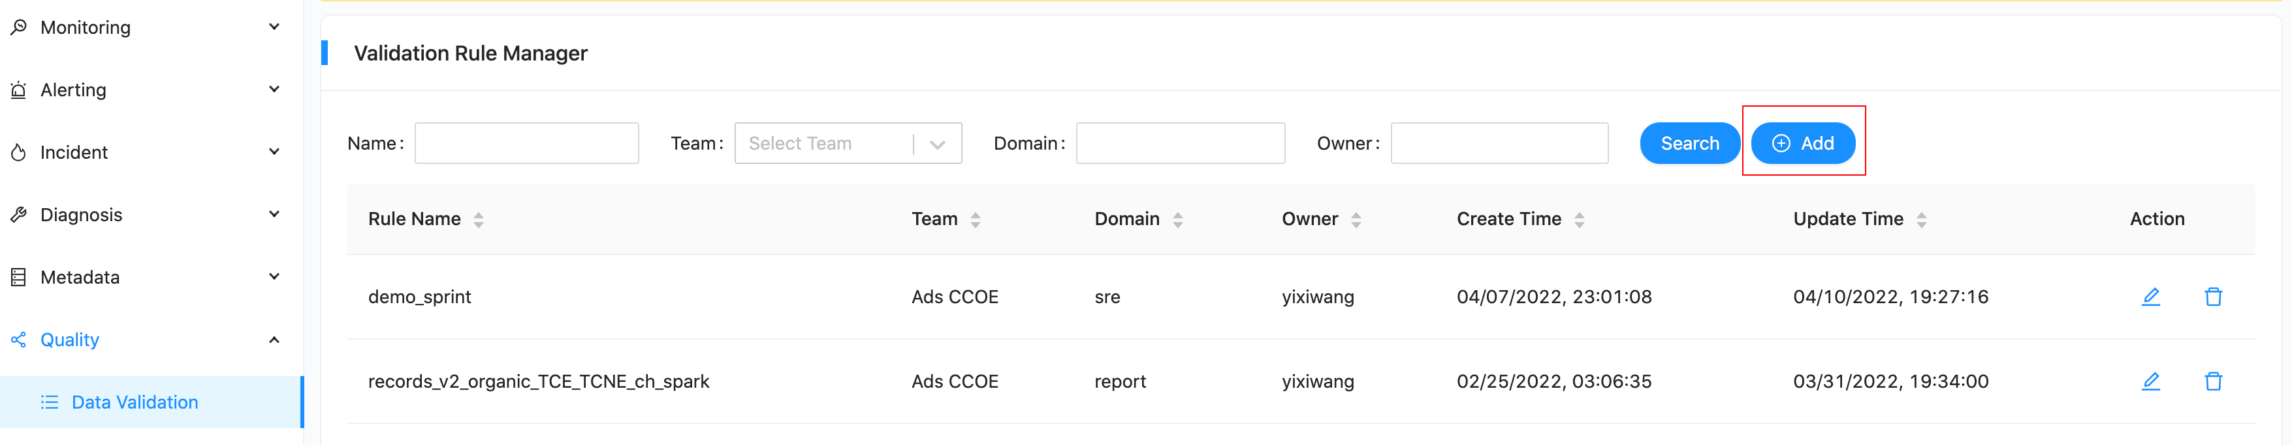

#### Fill in basic information

            Name, Owner, Team and Domain are necessary in this part.

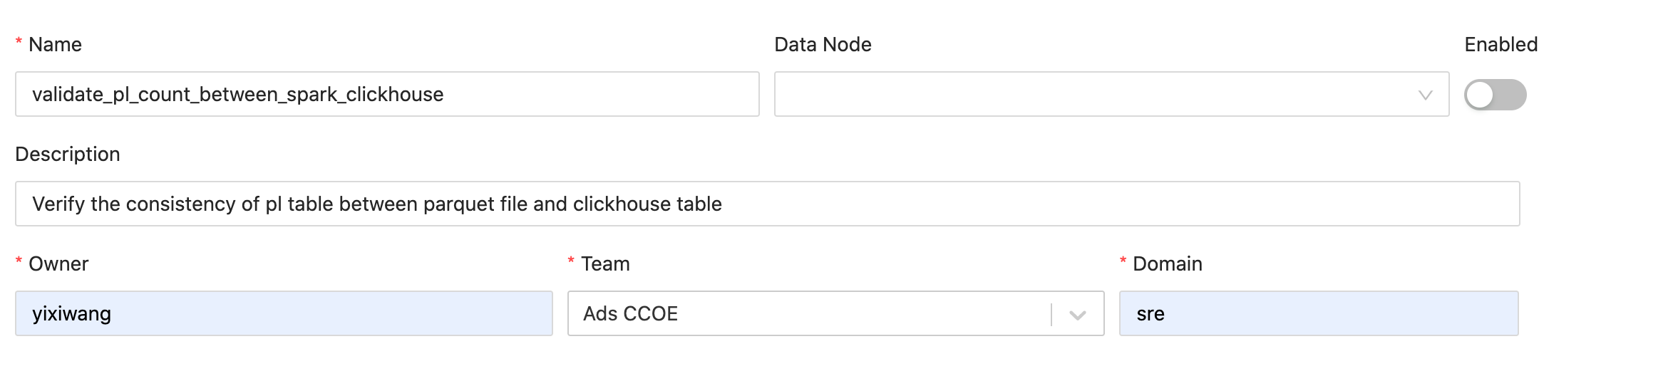

#### Add Accuracy rule

           To verify one table columns' accuracy, the rule will compare the metrics from hive/clickhouse/parquet file/es_index which is supported by metrics rule with corresponding thresholds.

           In order to avoid duplicate rule creation, you can create multiple accuracy rules in the same validation rule.

* + **Name**: The name of accuracy rule
  + **Rule/SQL**: Select the rule and sql name which you created in step 1
  + **Validation Columns**: Fill in the metric name which is selected in "Rule/SQL" stage
  + **Condition**: There are six options, equals, does not equals, less than, less than or equals, great than, great than or equals
  + **Threshold**: Threshold condition

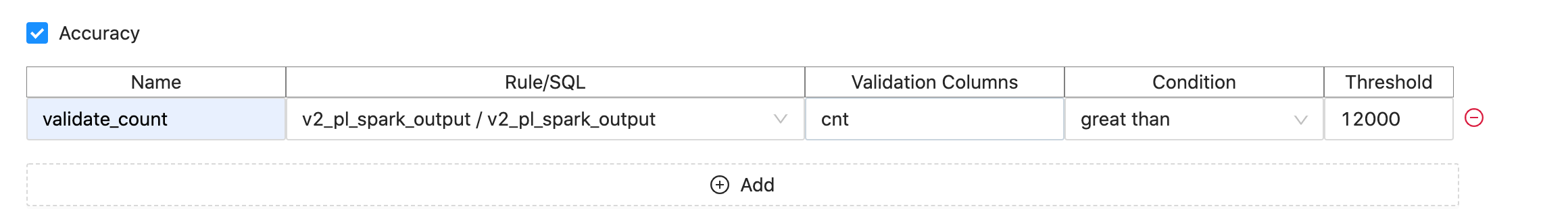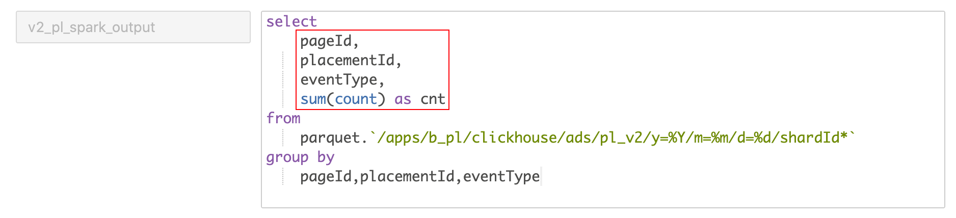

#### Add Consistency rule

           To verify cross table column's consistency, the rule will compare source table columns with target, V1 supports clickhouse, es, hive, parquet file.

* + **Name**: the name of consistency rule
  + **Origin**: Original table
  + **Target**: Target table
  + **Rule/SQL**: The rule and sql name which you created in step 1
  + **Compare Key**: The column that need to be verified in original and target table
  + **Mapping Key**: Primary key that used to specify unique data

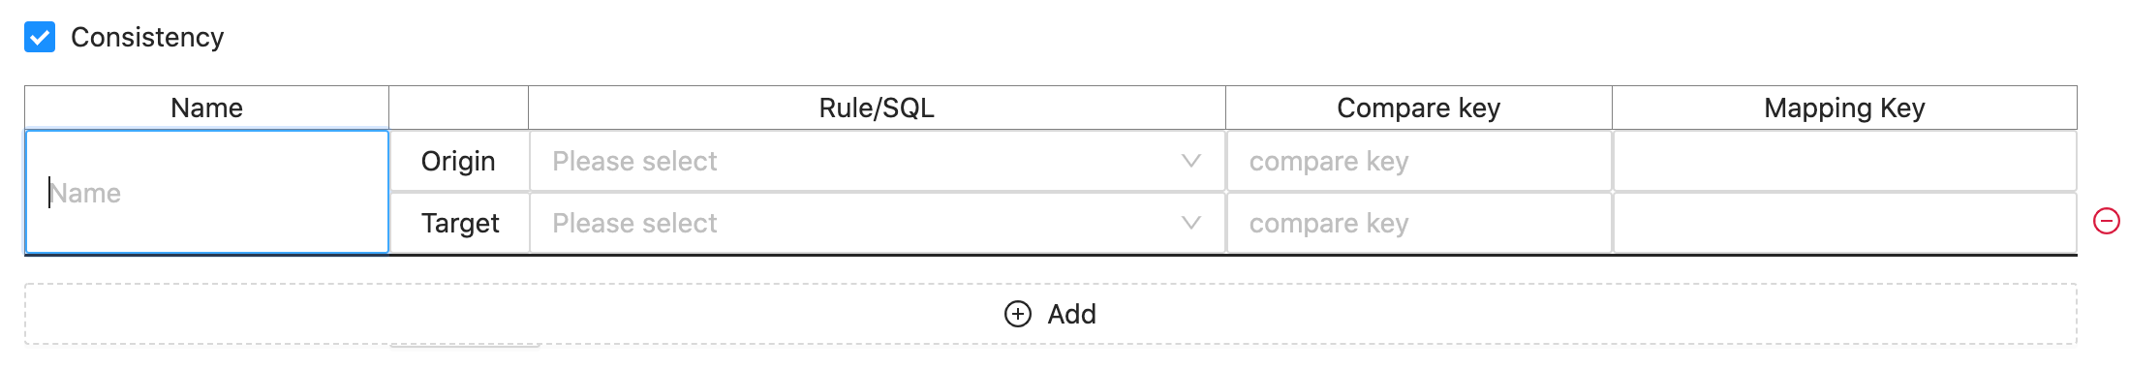

#### Add triggers parameters

* + **Schedule**: Crontab format string, [Crontab Generator](https://crontab.guru/)
  + **Backfill** **Time**: Time range
  + **Delta** **time**: The time duration from today

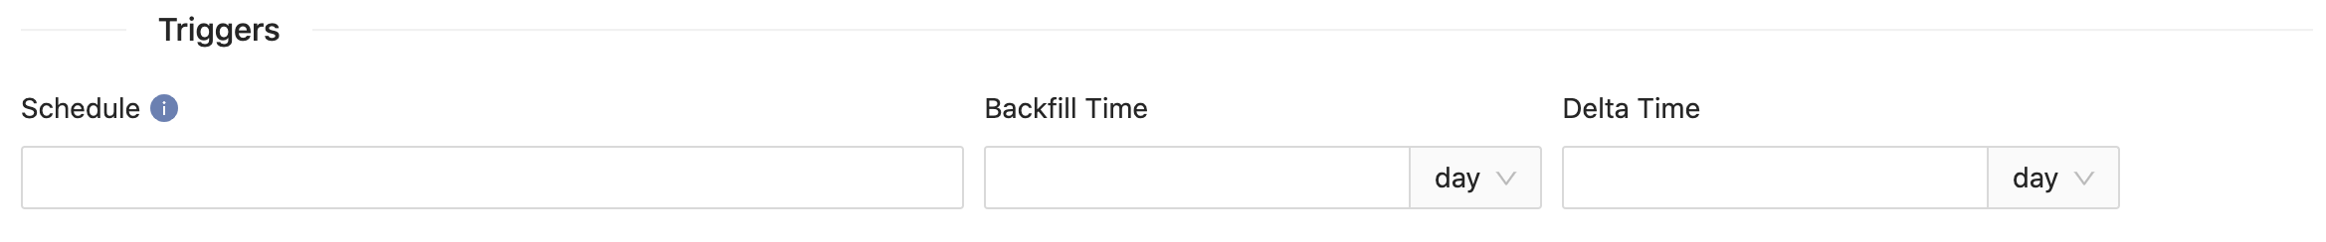

#### Add notifications

* + **Email**: Email prefix

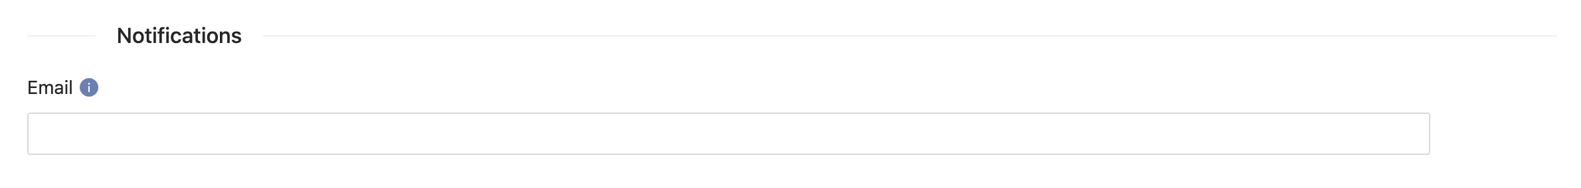

#### Select extra settings

* + **Email** **format**: Summary send(the email only send the final result of this rule(pass/deny), does not contain metrics details), Details send(the email send the final result and the metrics details)

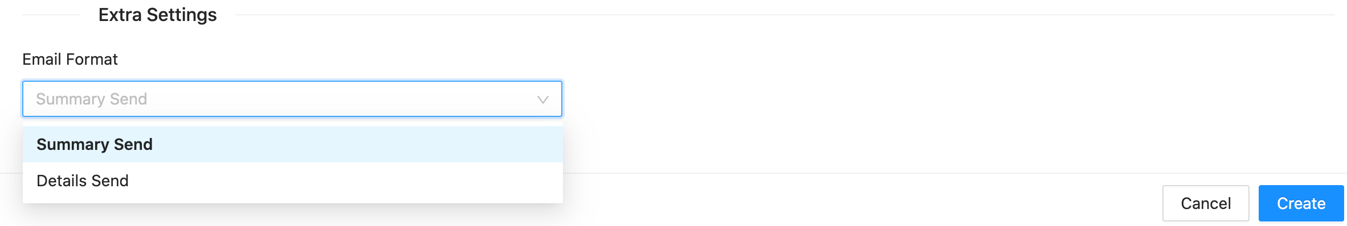

# Examples

## Data Consistency

In ClickFraud team, to daily validate the model offline and real-time metrics consistency, They create multiply validation rule in Control Center. There is an example which is verifying batch_cnt across offline and realtime table.

* Step1: Create metrics rules from offline and real-time parquet file. From the sql we can see metrics **count, distinct_count, fraud_cnt, icf_cnt, fraud_rate, fraud_rate_total, valid_cnt** will be generated with a default key **slot_timestamp** to indicate time info.

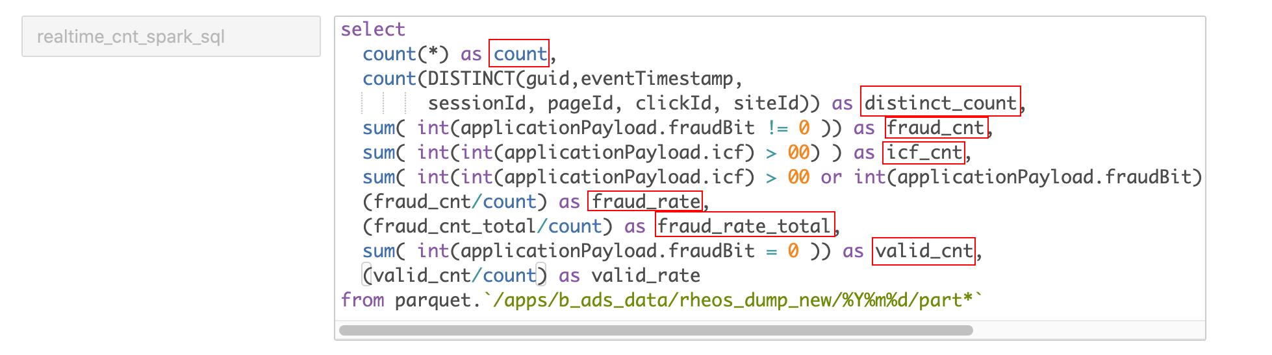

                                                 Real-time metrics rule

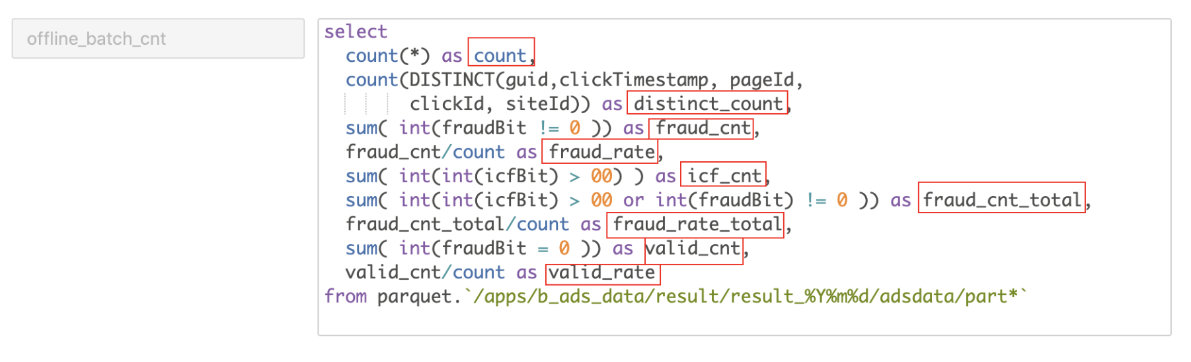

                                                 Offline metrics rule

* Step2: Create consistency validation rule.

           Take the rt_batch_cnt_count rule in the below figure as an example, it will compare the count field in the realtime_cnt/realtime_cnt_spark_sql table with the count field in the offline_batch_cnt/offline_batch_cnt table.

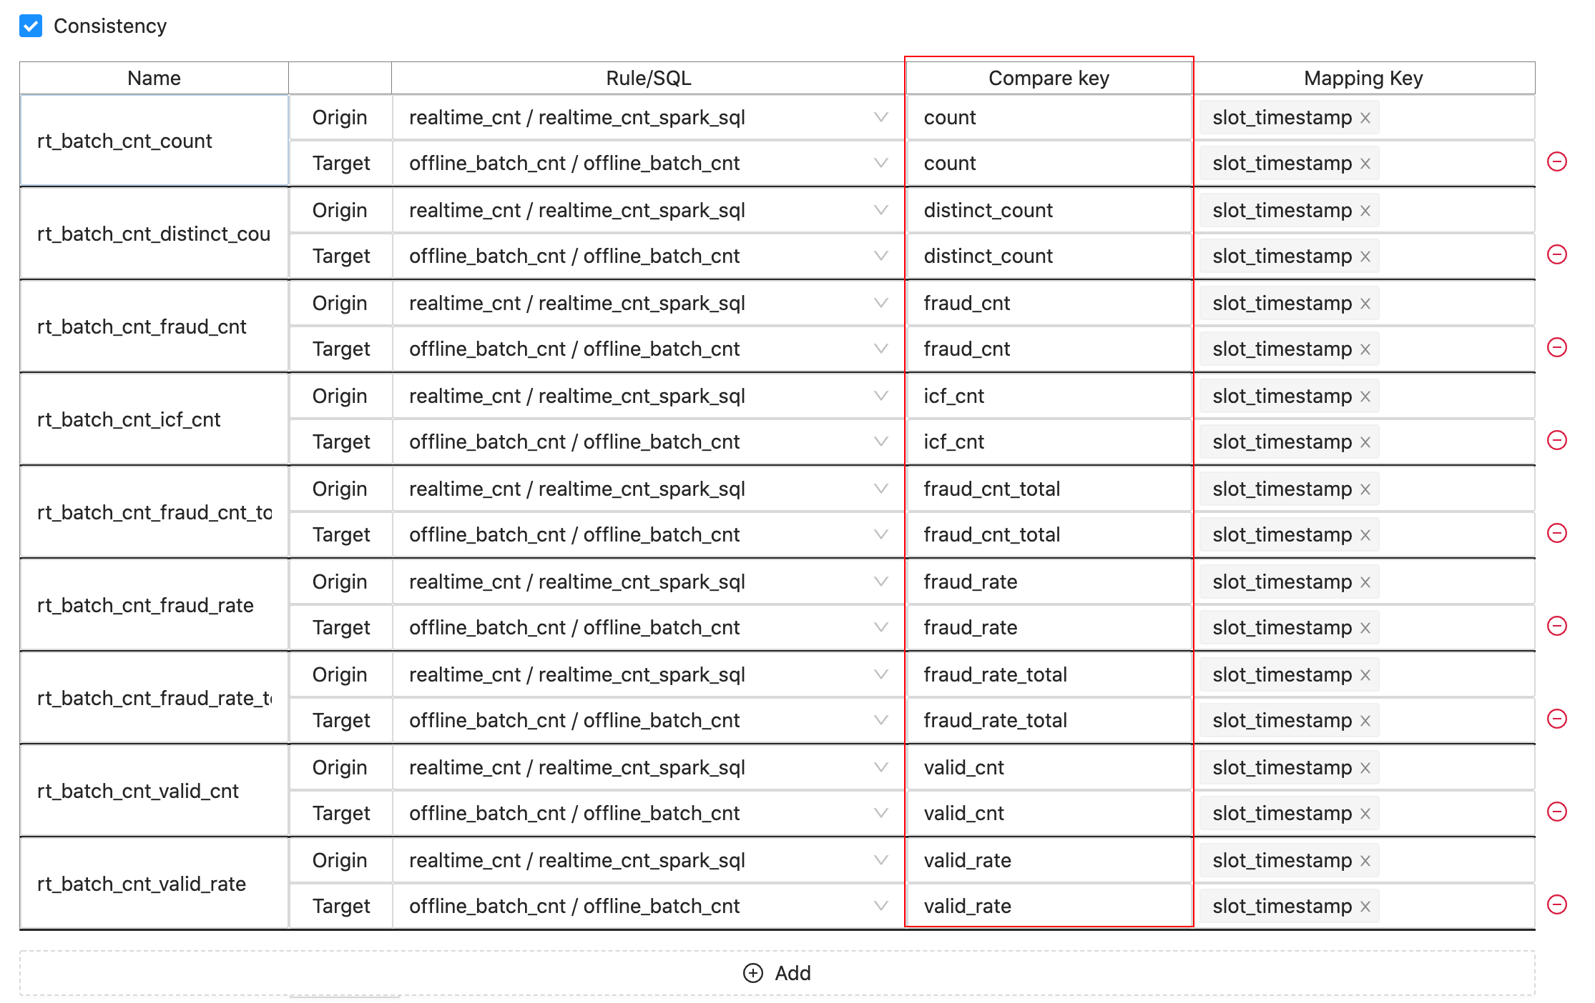

* Step3: As schedule was set up. Daily email report will be send out. You can also trigger validation by API to validate a certain date or date range.

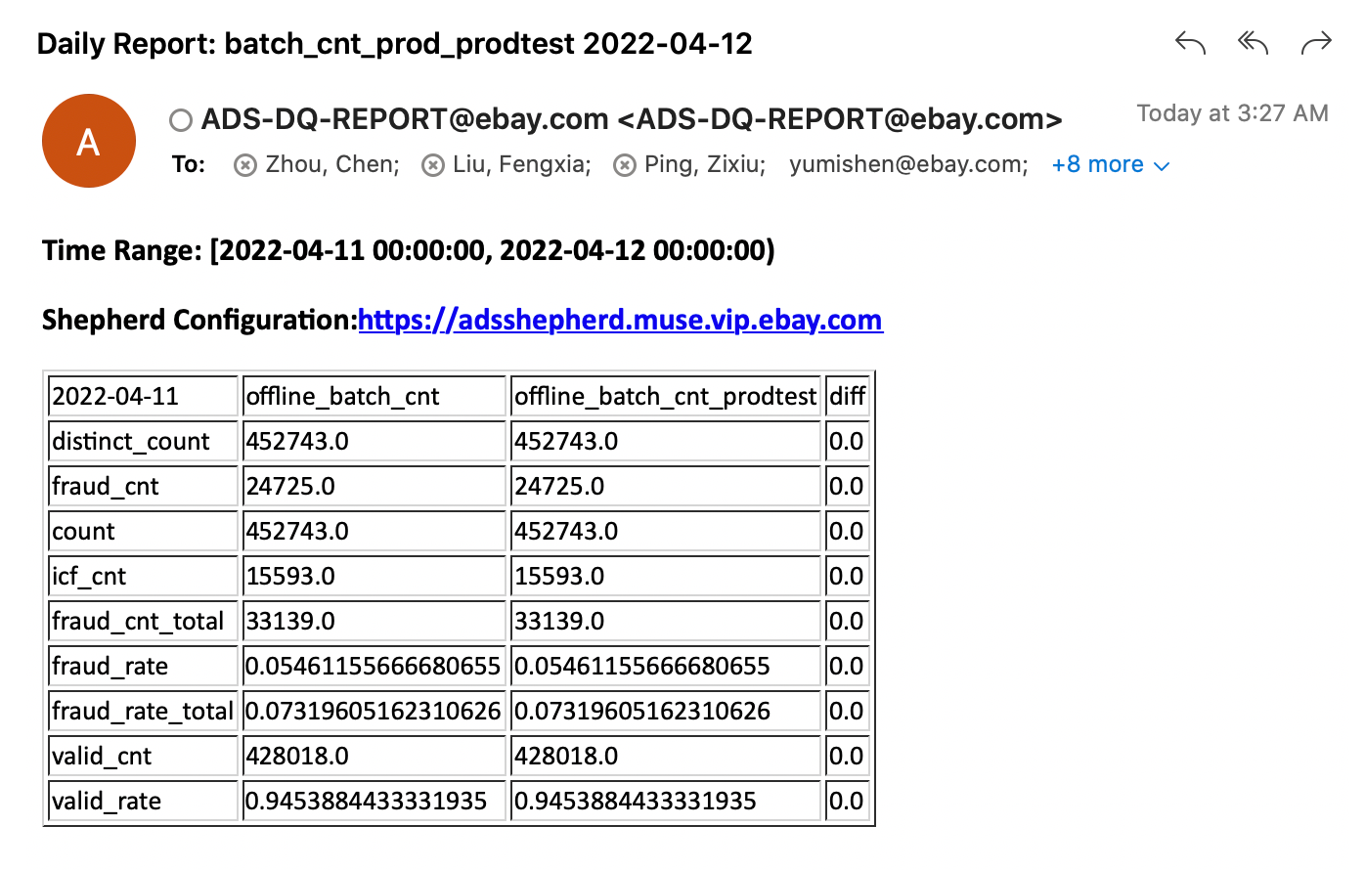

## Data Accuracy

There is a case to verify the quality of sellerId. In the ebay system, it is impossible for sellerId to have a negative value.

* Step1: Create metrics rules from pl_v2 clickhouse table. From the sql we can see metrics **sellerId** will be generated with a default key **slot_timestamp** to indicate time info.

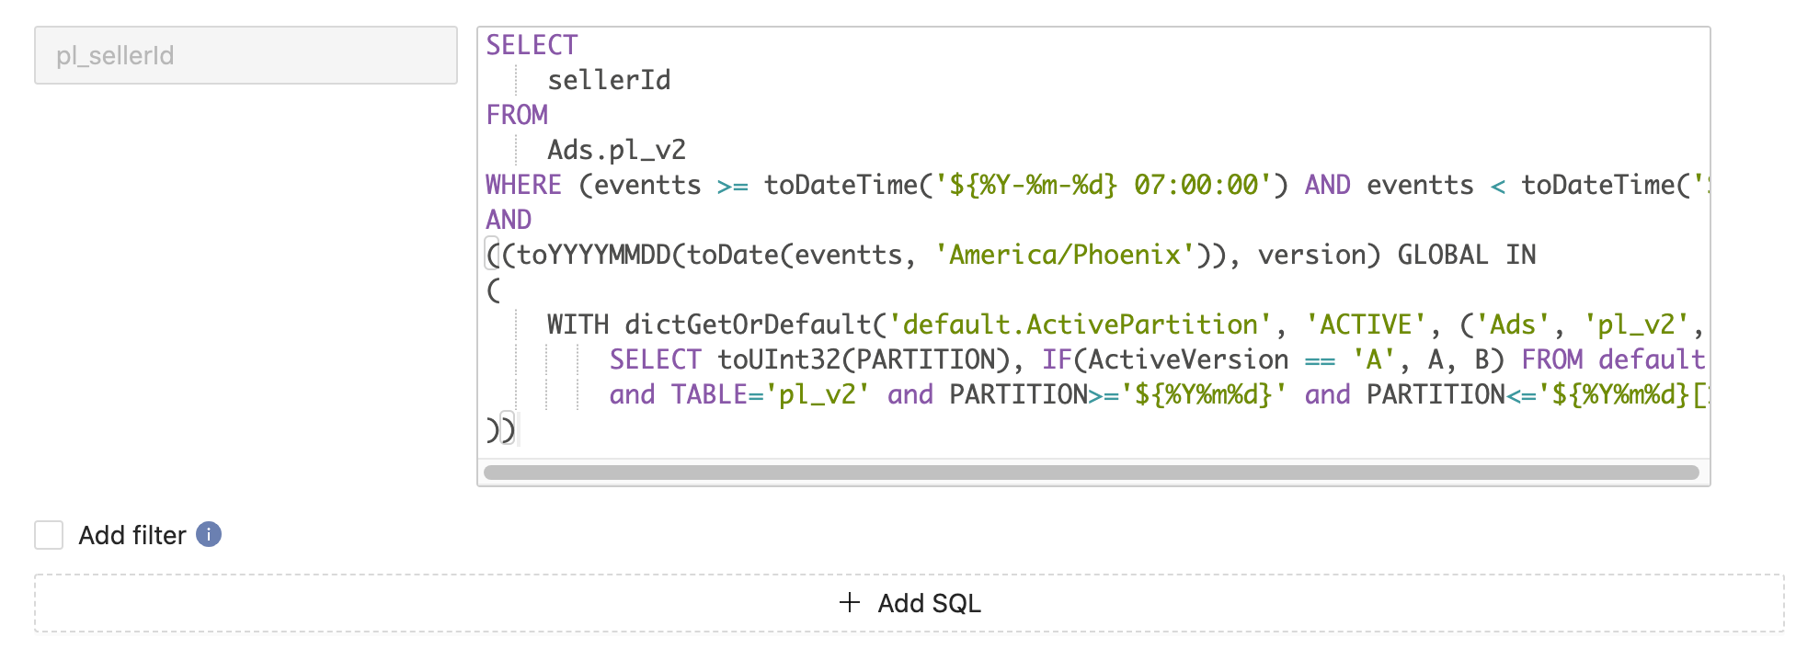

* Step2: Create accuracy rule

          Fill in the accuracy rule name, select the metrics rule and sql_name which you created in step1. Fill in validation columns which is selected in "Rule/SQL" stage. Condition and threshold fields are validation conditions.

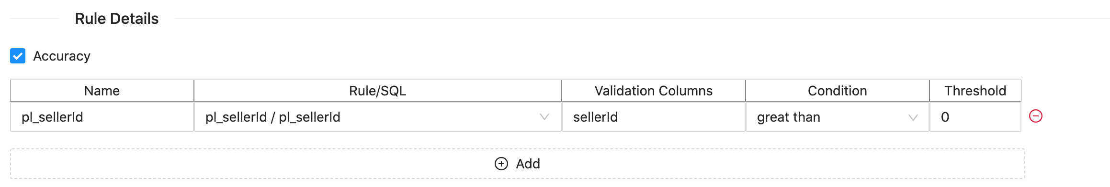

* Step3: As schedule was set up. Daily email report will be send out. You can also trigger validation by API to validate a certain date or date range.